| FULL LEGAL NAME | **LOCATION (COUNTRY)** | **EMAIL ADDRESS** | **MARK X FOR ANY NON-CONTRIBUTING MEMBER** |
| --- | --- | --- | --- |
| Olawale Omoniyi Akande | Nigeria | Waleomoniyi@hotmail.com |  |
| Shubhankit Singh | India | shubhubits313@gmail.com |  |
| Ebenezer Yeboah | Ghana | ebenezeryeboah46@gmail.com |  |

| **Statement of integrity:** By typing the names of all group members in the text boxes below, you confirm that the assignment submitted is original work produced by the group (excluding any non-contributing members identified with an “X” above). | |
| --- | --- |
| **Team member 1** | **Olawale Omoniyi Akande** |
| **Team member 2** | **Shubhankit Singh** |
| **Team member 3** | **Ebenezer Yeboah** |

| Use the box below to explain any attempts to reach out to a non-contributing member. Type (N/A) if all members contributed.  **Note:** You may be required to provide proof of your outreach to non-contributing members upon request. |
| --- |
|  |

**Step 1: Combined by the team.**

1. Yes, put-call parity applies to European options. Put-call parity is a principle that defines a relationship between the price of a European call option and a European put option, with identical strike prices and expiration dates. The fixed expiration date of European options simplifies the put-call parity relationship and allows for straightforward comparisons between the cash flows from call and put options.
2. The put-call parity equation is represented by:

$C-P=S_{0}-K×e^{-rt}$

Rewriting it to solve for the call price in terms of everything will be:

$C=P+S_{0}-K×e^{-rt}$

1. The put-call parity equation is represented by:

$C-P=S_{0}-K×e^{-rt}$

Rewriting it to solve for the put price in terms of everything will be:

$P=C+K×e^{-rt}-S_{0}$

Where:

* *C* is the price of the European call option
* *P* is the price of the European put option.
* $S_{0}$ is the current stock price.
* *K* is the strike price of the options.
* *r* is the risk-free interest rate.
* *t* is the time of expiration.

1. Put-call parity applies to American options if they are exercised only at expiration, similar to European options. Unlike European options, American options provide the flexibility for the holder to exercise the option at any time before or on the expiration date. However, put-call parity may not hold for American options if they are exercised before the expiration date.
2. Part A

Number of steps for reliable estimate for:

. The European call option is 50

. The European put option is 60

Part B

The option price is obtained by following the following process:

We define the option parameters such as C, P, S, K, r, t, sigma, u, d, and p. Then we create a binomial tree starting with the current price of the asset with two possible outcomes in the next step. Next we calculate the terminal payoff at the final node (step N)

[$Call payoff = max(S-K, 0); put payoff = max(K-S, 0)]$

Then discount the payoff backward and apply the risk-neutral probability to the payoff path. This process is repeated till we reach the root of the tree.

The price of the European call option converges at N=50. Therefore, we have a reliable price estimate for the call option price at 50 steps. While the price of the European put option converges at N=60, there We have a reliable price estimate for the put option at N=60 stops.

1. Part A

The Greek Delta for the call option at time t=0 is observed to be higher than that of the call option. The Delta for both are also opposite in direction; positive for the call option and negative for the put option.

Part B

Delta tells the sensitivity of the option price to changes in the price of the underlying asset. A positive delta for call option makes sense because the option payout is expected to increase with increase in price of the underlying asset while negative delta is for put as they are expected to move opposite direction.

1. Part A

From the result obtained, we see that delta increased with increased volatility (from 20% to 25%). This shows that the prices of options change at a greater magnitude for the same parameters of options when volatility increases.

Part B

For every dollar increase in the price of the underlying, the call option price increases by 58.36 cents at 20% volatility and 57.33 (1.03 cents more) at 25% volatility. While for every dollar increase in the price of the underlying, the put option price decreases by 42.10 cents at 20% volatility and 42.98 (0.88 cents more) at 25% volatility.

1. ***Part A:***   
   The computed prices were $4.60 for the American call option, and $3.47 for the American put option. These results reflect the value of the options considering the availability of early exercise, a feature exclusive to American options.  
   ***Part B :***   
   We ended up choosing 50 steps in the binomial tree because of two main reasons :   
   ***Accuracy and Computational Efficiency***  
   A constant trade-off is required between Computational time and resources and Accuracy here, and 50 provides a good balance between both. Also, law of diminishing returns kicks in when we try increasing the steps more and more. Hence, this number of steps is generally considered sufficient for providing a good approximation of the actual value of the option.
2. ***Part A :***   
   Delta was **0.569 for the call option**, which indicates that for a price increase of approximately 57 cents, every $1 increases the underlying asset's price. **For the put option, Delta was -0.451,** meaning the option's price increases by approximately 45 cents for every $1 decrease in the underlying asset's price.  
   ***Part B :***   
   The positive Delta for the call option and negative Delta for the put option are consistent with theoretical expectations. Delta not only measures sensitivity to price changes but also offers insights into hedging strategies. The sign and magnitude of Delta provide information on the direction and proportion of the hedge required to offset price movements in the underlying asset.
3. ***Part A :***   
   The increase in volatility led to a price increase of $0.98 for both the call and put options. This demonstrates the options' value sensitivity to changes in volatility, as higher volatility increases the potential for profitable price movements before expiration. The actual values are in the python notebook, but we have approximated the values to $0.98 here.  
   ***Part B :***   
   The impact is similar on both the call and put options. The options' prices due to increased volatility underscores the non-directional nature of volatility's effect on option values. It highlights the importance of volatility in options pricing, irrespective of the option type, because it affects the probability distribution of future stock prices and, thus, the potential for the option to end in the money.
4. The put-call parity formula is given by $P=C+K×e^{-rt}-S_{0}$

Where P = 3.37, C = 4.61, S = 100, and $Ke^{-rt} = 98.76$ as computed and seen above.  
Whenever there are temporary market inefficiencies, deviations on the put-call parity create some riskless profit-making opportunities that may be exploited by sophisticated traders to create riskless positions.

* Arbitrage Opportunities: These opportunities result from a departure from the put-call parity which enables a trader undertake a guaranteed arbitrage. A discrepancy of European call and put options prices from the parity relationship provides this opportunity for exploiting pricing anomalies where one can simultaneously buy the under-priced option while selling an overpriced one. This implies that traders can build up a risk-free arbitrage position in such instance, hence earning money devoid of any exposure to market risk.
* Market Efficiency and Pricing Transparency: Put-call parity is an essential standard against which efficiency and transparency in the options markets are evaluated. By making sure that European call and put options meet with the conditions required by put-call parity, we contribute towards fair and transparent markets. When investors adjust their pricing mechanisms as well as trading strategies so that they follow this unique relation between European call and put options, it will enhance efficiency in terms of price discovery. By adhering to put-call parity, market participants can implement sophisticated hedging techniques and minimize their portfolio's overall risk exposure.
* Risk Management and Hedging Strategies: Market participants have effective tools for managing risks through maintaining the put-call parity among other tools. The relationship between call and put prices helps traders develop various hedging strategies designed to guide them in adjusting their transactions.

When Put-Call Parity is temporarily violated due to market inefficiencies or mispricings, sophisticated traders are incentivized to exploit these opportunities for arbitrage profits by creating riskless positions.

* Arbitrage Opportunities: Traders keenly monitor deviations from put-call parity as they present opportunities for riskless arbitrage. When the prices of European call and put options diverge from the parity relationship, traders can exploit the mispricing by simultaneously buying the underpriced option and selling the overpriced option. This creates a riskless arbitrage position that locks in profits without exposure to market risk.
* Market Efficiency and Pricing Transparency: Put-call parity serves as a critical benchmark for evaluating the efficiency and transparency of the options market. Ensuring that European call and put options satisfy put-call parity promotes market integrity and fairness. It encourages market participants to adjust their trading strategies and prices to align with the parity relationship, thereby contributing to more efficient price discovery mechanisms.
* Risk Management and Hedging Strategies: Maintaining put-call parity facilitates effective risk management and hedging strategies for market participants. Traders and investors rely on the parity relationship to construct hedging positions that offset exposure to directional market movements.

1. For American options, the parity holds with slight modifications due to the possibility of early exercise. Considering the above with C = 4.61, P = 3.48, S = 100 and $Ke^{-rt} = 98.76$, $P≠C+K×e^{-rt}-S_{0}$.

American options, unlike their European counterparts, are influenced by various factors such as dividends and interest rates. Dividends paid on the underlying asset can significantly impact early exercise decisions, particularly for American call options. These unique characteristics of American options can lead to deviations from the simple Put-Call Parity formula. In cases where a stock is about to pay dividends, arbitrage opportunities may arise. Arbitrageurs can exploit these opportunities by purchasing the stock, exercising an American put option, and receiving the strike price before the dividend is paid, effectively allowing them to capture the dividend. These factors underscore the complexities and nuances inherent in American options pricing and their impact on the Put-Call Parity relationship.

1. The European call is equal to the American call. They all have values of 4.61.
2. The European put is less than the American put. The European put has a value of 3.37 and the American put has a value of 3.48. The difference is 0.08. Differences in early exercise opportunities and dividend capture opportunities contribute to varying values between American put options, which allow exercise at any time, and European put options, which permit exercise only at expiration. Additionally, interest rate differentials influence the relative pricing of these options.
3. ***Part A:***  
   The European call option prices for strike prices at 90, 95, 100, 105, and 110 are $11.67, $7.72, $4.61, $2.49, and $1.19, respectively for the strike prices.  
   ***Part B:***  
   The trend observed in call option prices decreases as we move from deep OTM to deep ITM. This trend makes sense because the deeper OTM an option is (lower strike price relative to the stock price), the less likely it is to be exercised profitably, and thus it is cheaper. Conversely, as the options become more ITM (higher strike price relative to the stock price), their value increases because they are more likely to be exercised profitably, but the actual price of the option decreases because the intrinsic value becomes a larger proportion of the option price, which is already factored into the current stock price.
4. ***Part A :***The European put option prices for the same strike prices are $0.55, $1.54, $3.36, $6.18, and $9.83, respectively.  
     
   ***Part B :***  
   The trend in put option prices is increasing as we move from deep OTM to deep ITM, which is the opposite of the call option trend. This is logical because the more ITM a put option is (higher strike price relative to the stock price), the more valuable it is due to the greater likelihood that the option will be exercised profitably. Conversely, as put options become more OTM (lower strike price relative to the stock price), their value decreases because they are less likely to be exercised profitably.

The trend observed for both call and put options is consistent with financial theory, validates put call parity, and reflects the intrinsic value and probability of exercise that are priced into options. The observed prices align with the typical behavior of European options where the value of calls decreases and the value of puts increases with the moneyness moving from deep OTM to deep ITM.  
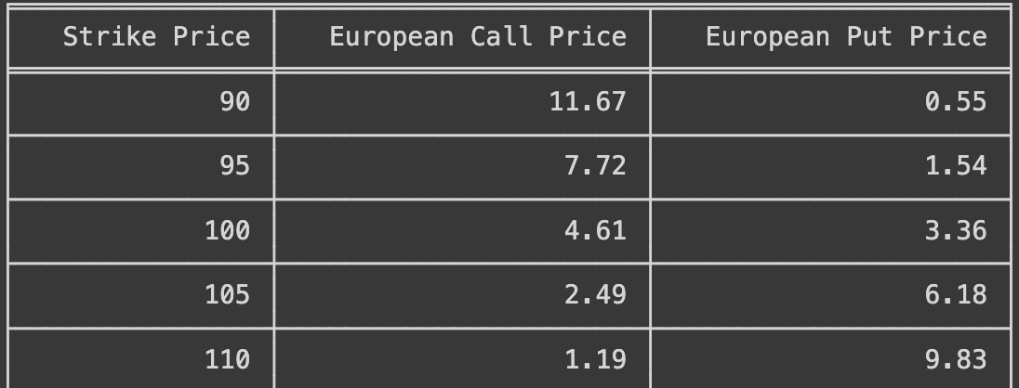  
Table for European options calculated using the trinomial method for Q15,16

1. 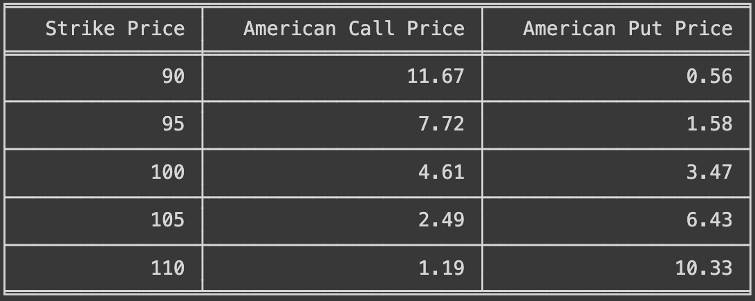

Table for American options calculated using the trinomial method for Q17,18



1. The put-call parity holds true because of the principle of no arbitrage in financial markets. Essentially, if there were a discrepancy between the prices of European call and put options with the same strike price and expiration date, traders could exploit this difference to make riskless profits, leading to arbitrage opportunities.
2. The put-call parity holds false because of mispricing or market inefficiencies which leads to arbitrage.

3. I. As the seller of the put option, I'm obligated to buy the stock at $182 if its price falls below this level at maturity. To manage this risk, I employ Delta hedging, adjusting my stock holdings according to the put option's delta throughout the trading period.

Initially, the put option's delta is around -0.5. To mitigate potential losses, I purchase 0.5 shares of the stock, maintaining a neutral position if the stock price remains at $180 by step 1.

Progressing to step 1, where the stock price rises to $219, the put option's delta decreases to approximately -0.3. Consequently, I sell 0.3 shares of the stock to balance my position against potential losses if the stock price remains at $219 by step 2.

At step 2, should the stock price decline to $182, the put option's delta reverts to -0.5. To fulfill my obligation to buy the stock at $182, I purchase 0.5 shares, ensuring compliance with the agreed-upon strike price.



I. As the seller of the put option, I'm obligated to buy the stock at $182 if its price falls below

|  | Stock | Shares | Delta | Cash Account |
| --- | --- | --- | --- | --- |
| 0 | 180 | 0.5 | -0.5 | 180.00 |
| 1 | 219 | 0.15 | -0.3 | 181.85 |
| 2 | 182 | 0.25 | -0.5 | 182.10 |

27. The delta for the Asian put option has much complexity is influenced by the historical prices of the Asian put option that results in the average value. This is in addition to the influence of the current price of the underlying asset while the delta of an American option counterpart is only influenced by the current price of the underlying.

The delta hedging process for an Asian put option involves dynamic adjustments based on changes in the average price of the underlying asset. The investor buys or sells the underlying asset to maintain a delta-neutral position.